Step-1: Launch EC2 instance and connect it to VM

Step-2: go to /mnt folder create a .sh file = (Arithmatic.sh)

1. Sudo su - =go to root user
2. Cd /mnt = go to mnt directory
3. Vi arithmetic.sh = create .sh file for write shell script in it.

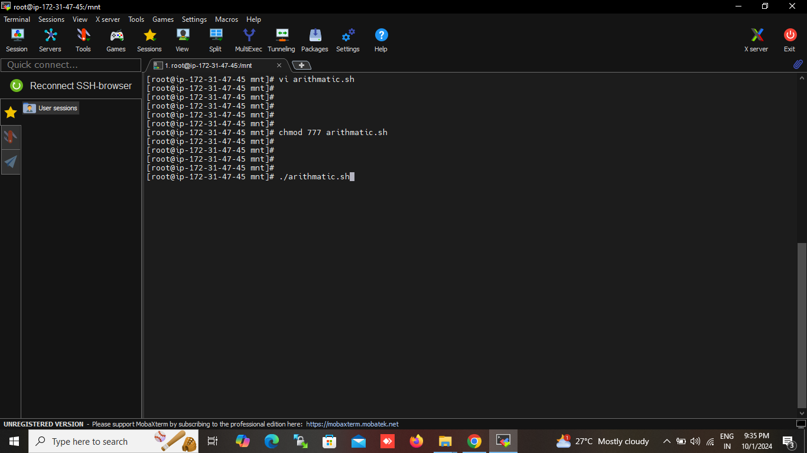

1. Write a simple shell script start with shbang statement = #!/bin/bash
2. #!/bin/bash

a=30

b=10

echo “Addition: $(expr $a + $b)”

echo “substraction: $(expr $a - $b)”

echo “multiplication: $(expr $a \\* $b)”

echo “division: $(expr $a / $b)”

echo “modulus: $(expr $a % $b)”

1. save the file and exit

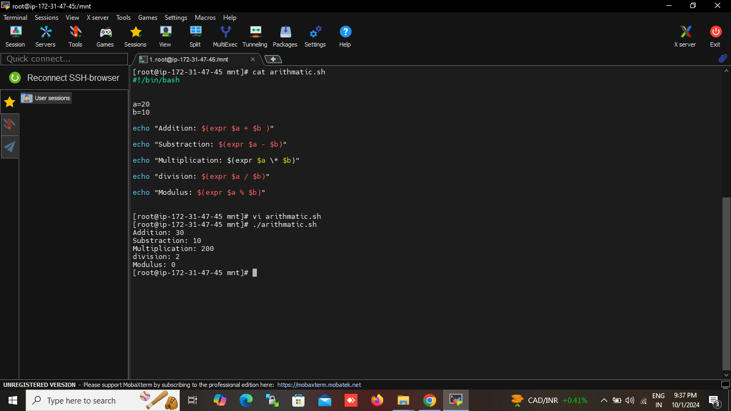

Step-3: set the permission to .sh file (give executable permission)

1.chmod 777 arithmatic.sh

Step-4: execute the file

1. ./arithmetic.sh

